How to Time Synchronize a PMC-53M in ION Enterprise
The PMC-53M meter has time registers providing timestamps for data logs. It can be time synchronized through communication.
This technical note describes how to time synchronize a PMC-53M in ION VISTA.
It assumes that the users are familiar with ION Enterprise Modbus Device Importer utility and Modbus register maps of PMC-53M.

Reference documentation:
- PMC-53 Series User Manual V.pdf
- Modbus_Device_Importer.pdf
- Modbus_and_ION_Technology.pdf
- ION_Enterprise_5.6_User_Guide.pdf

The PMC-53M meter’s serial port has been configured with the following parameters:
- Type = RS485
- Baud rate = 9600
- Data Bits = 8
- Parity = None
- Stop Bits = 1
- UnitID=100

Creating the Modbus Map File for PMC-53M with ION Enterprise MDI Utility
Use the ION Enterprise Modbus Device Importer utility to configure the PMC-53M Modbus device (mapping information) and add it as a Device Type to the Network Configuration database (NOM). All time registers need to be pre-defined in the Modbus map file (.ion).
- Launch Management Console. Enter the right user name and password to login. Two default user names (“guest” and “supervisor”) are both with a default password of “0” (zero).
- Navigate to ToolsSystemModbus Device Importer… from the Management Console user interface.
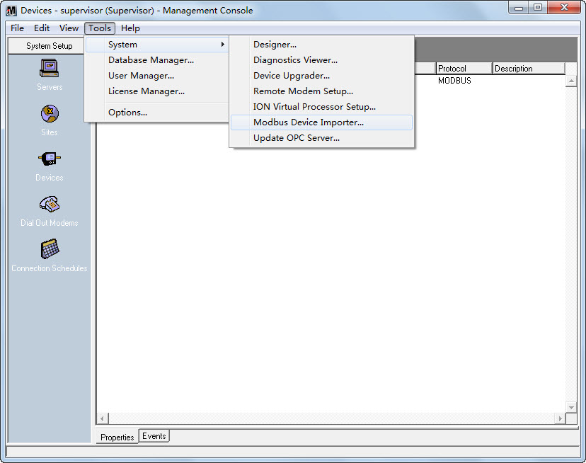
And the main console appears as follows (modbus_default.ion):
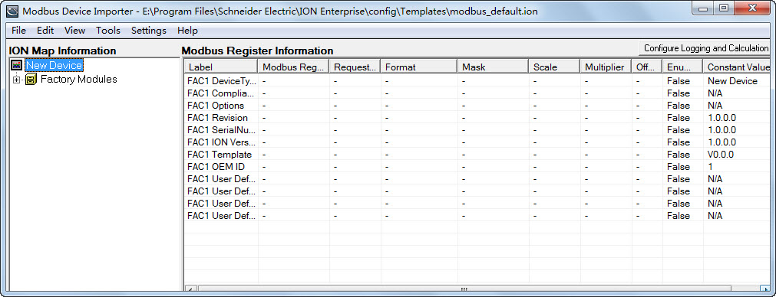
- Right-click the New Device icon from the left pane in the ION Map Information region. Select Advanced Properties from the pop-up dialog box.
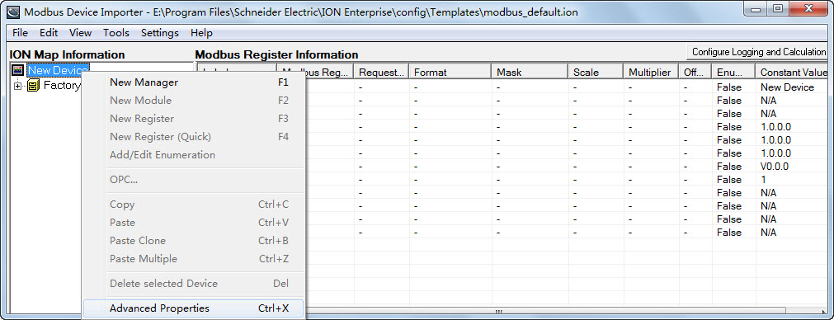
The Device Properties dialog box is shown as follows:
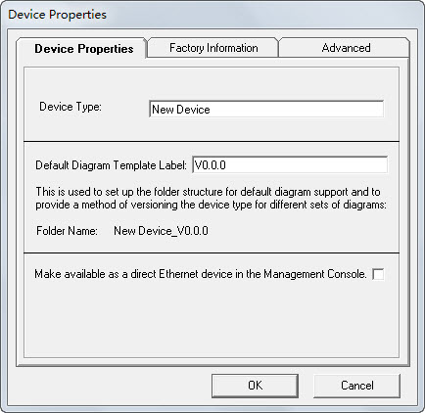
Configure the Device Properties according to your application.
Device Properties Tab
- Device Type: Type the name of the Device Type. For example, name the device as PMC53M if the device model is PMC-53M meter.
- Default Diagram Template Label: The string entered in this field is an internal identifier for the device.
Configure the Device Properties according to your application.
Advanced Tab
- Device Type: Type the name of the Device Type. For example, name the device as PMC53M if the device model is PMC-53M meter.
- Multiple Preset Write check box: Be sure that this check box is selected. PMC-53M requires Multiple Preset Write for time registers so that all time registers be written in a single transaction.
Other settings beneath this tab do not need to be changed.
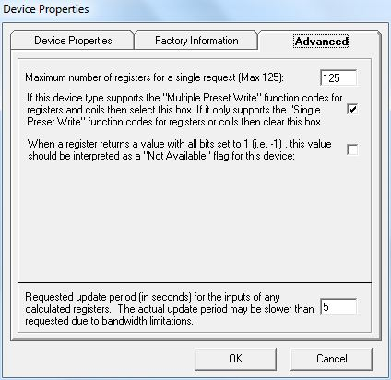
- Right-click the New Device icon from the left pane in the ION Map Information region. Select New Manager from the pop-up dialog box.
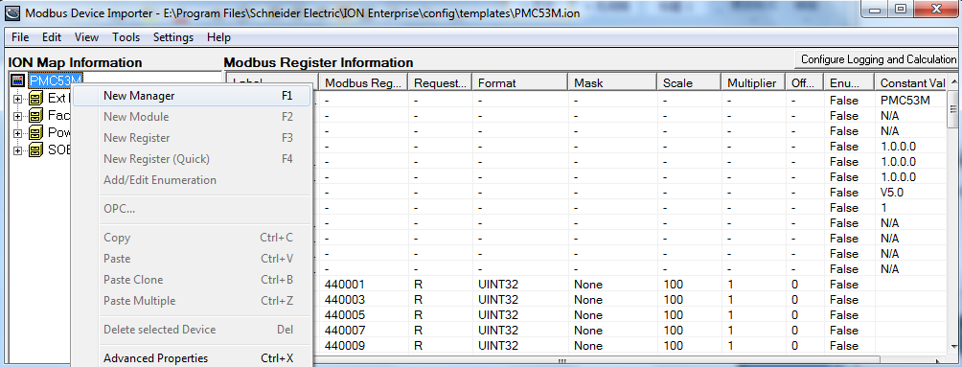
The Add New Manager dialog box appears.
Enter the new manager name into the Manager Name box and select External Numeric Manager type from the Manager Type drop-down button. The manager type determines parameters in the modules and registers under it. The PMC-53M’s time registers are numeric registers.
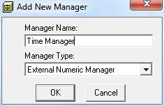
- Right-click the Manager icon from the left pane in the ION Map Information region. Select New Module from the pop-up dialog box.
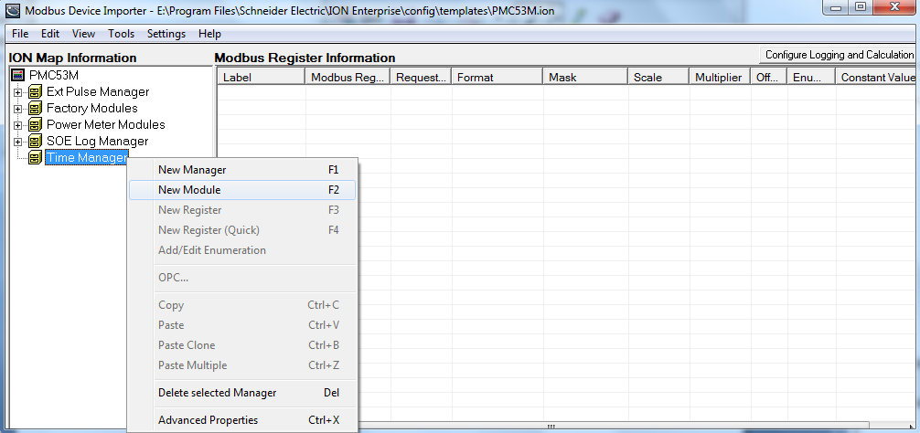
The Add New Module dialog box appears. Enter the new module name into the Module Name box and then click OK. For example, name the module as Clock Module to identify the time parameters.
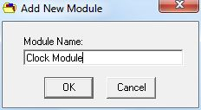
- Right-click the Module icon from the left pane in the ION Map Information region. Select New Register from the pop-up dialog box.
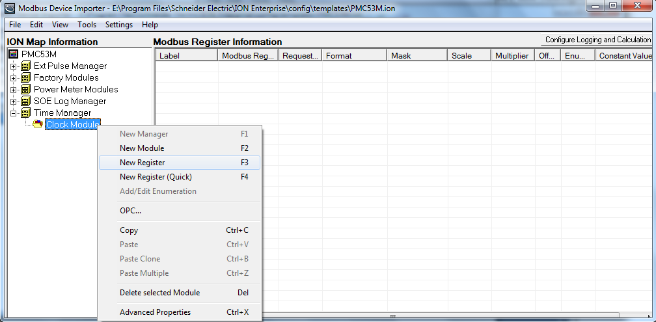
The register properties dialog box appears.
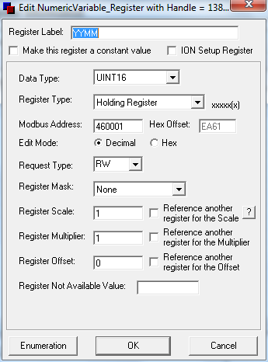
Register Properties
- Register Label: The label is an identifier for the register. For example, name the register as Vln a to identify the phase A voltage.
- Data Type: The data type is used for decoding the values returned from the meter. The selected data type format must match the format delivered by the device. Refer to the Modbus register map for the specific device.
- Register Type: It changes the most significant number in the Modbus address to correspond to the specified register type. The register type must match the register type specified by the device documentation.
- Modbus Address: This is the physical address of the specified register. It must match the register type specified by the device documentation.
- Request Type: This tells the system whether or not it can read, write or do both actions to the specified register. It must match the register type specified by the device documentation.
- Register Scale: This specifies what the scale factor of the data being requested should be. It must match the register type specified by the device documentation.
If all necessary parameters are configured, click OK and return to the main console. The new register appears under the tree in the left pane and detailed information of the register is shown in the right pane.
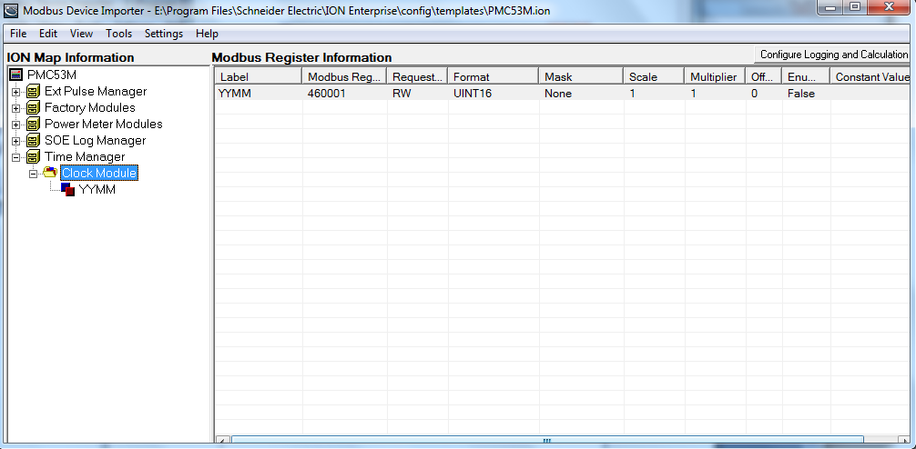
- Add the other time registers according to the device’s Modbus time registers map.
The following shows all the time registers that have been configured.
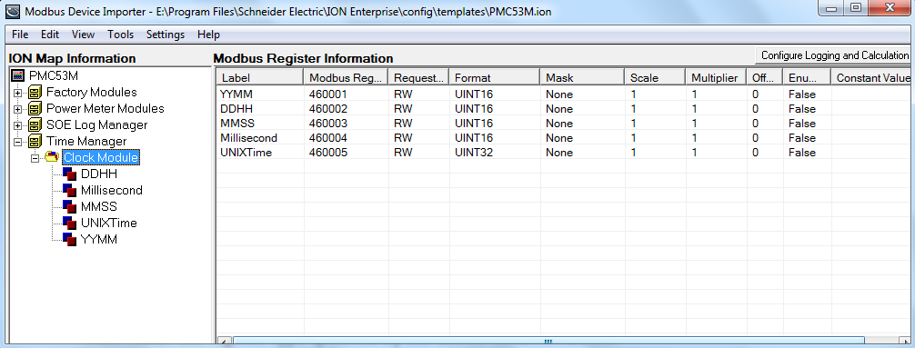
- After adding all the time registers, first navigate to FileSave to save the template, and select ToolsUpdate Device Type to update the NOM to reflect these changes.
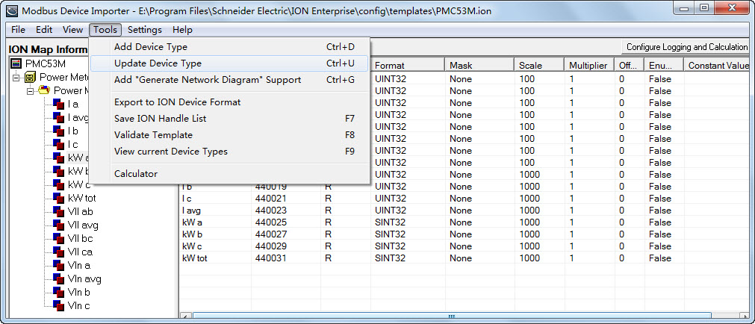
When the hint “Device updated successfully” appears, it indicates that the changes have been updated to the NOM successfully.
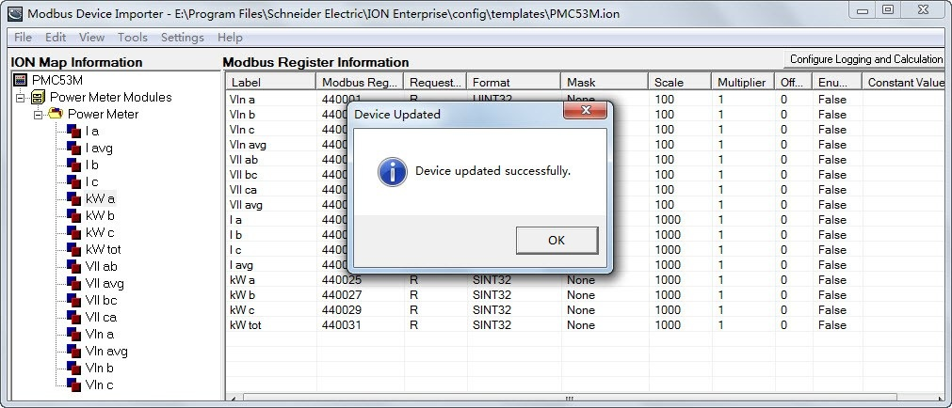

Setting Up Your Network in Management Console
- Launch Management Console. Enter the right user name and password to login. Two default user names (“guest” and “supervisor”) are both with a default password of “0” (zero).
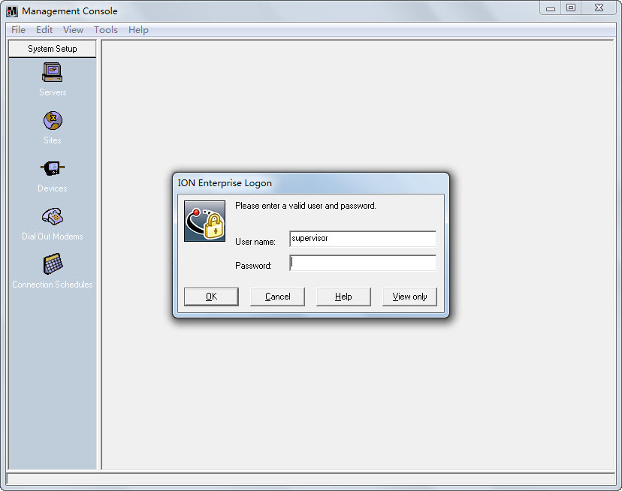
The program interface appears as follows with the default local server:
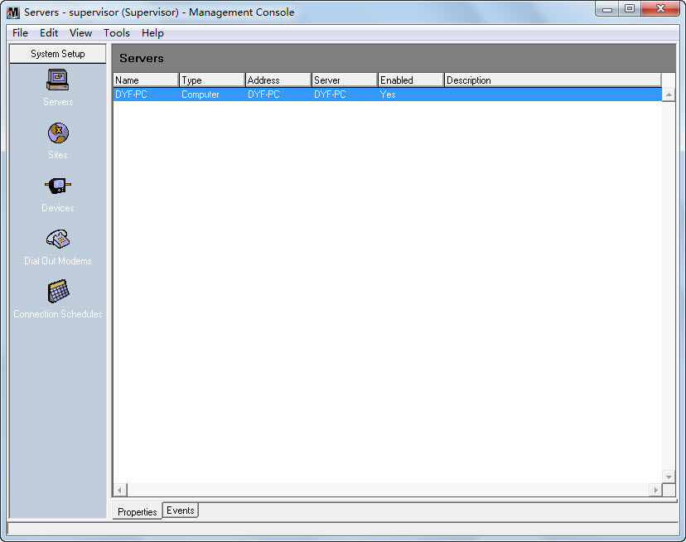
- Click the Sites icon on the left pane. Create and connect to a “Direct Site” with the proper baud rate and serial port.
- Right-click in the display window and select NewDirect Site….
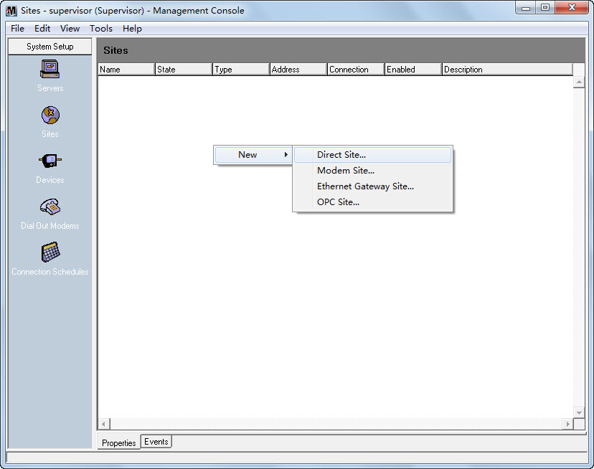
- The Direct Site Options dialog box appears as follows:
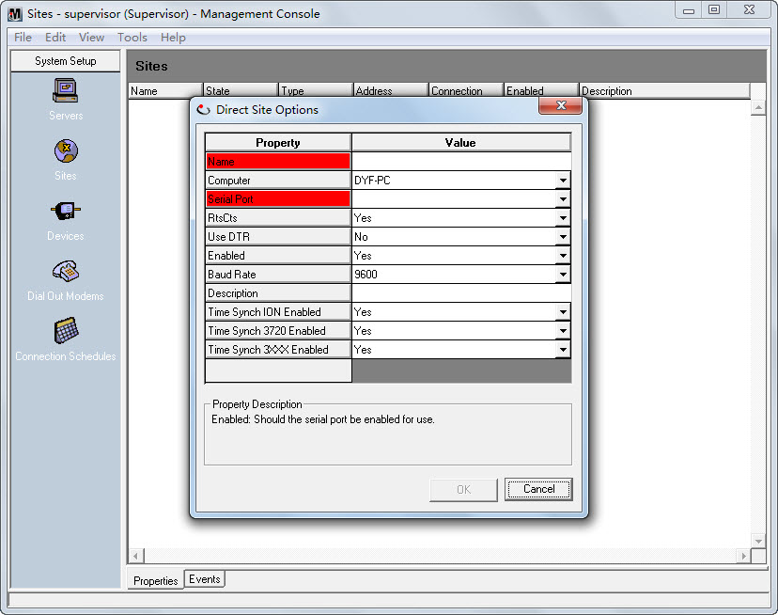
- Right-click within the dialog box and select Advanced Properties.
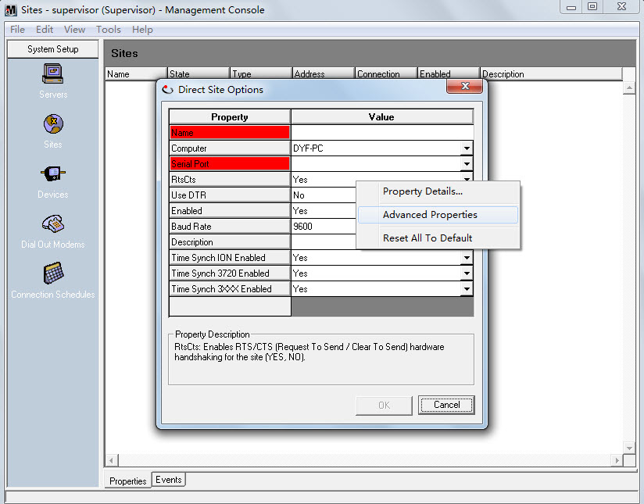
- Fill in the Name and Serial Port fields. Configure the Baud Rate, Transmit Delay, Data Bits, Stop Bits, and Parity fields to match the communication settings in the device. Change other fields if required.
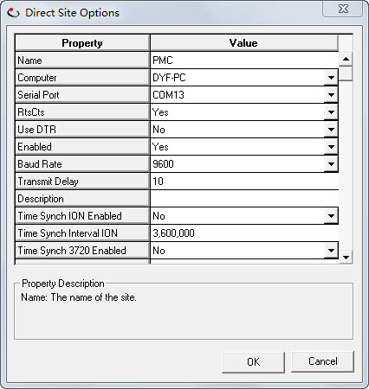
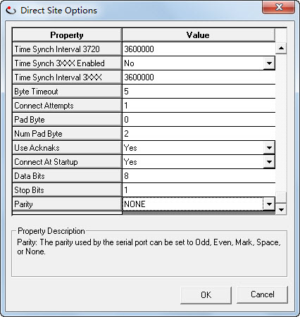
- Right-click on the new site, and select Connect to connect the serial site.
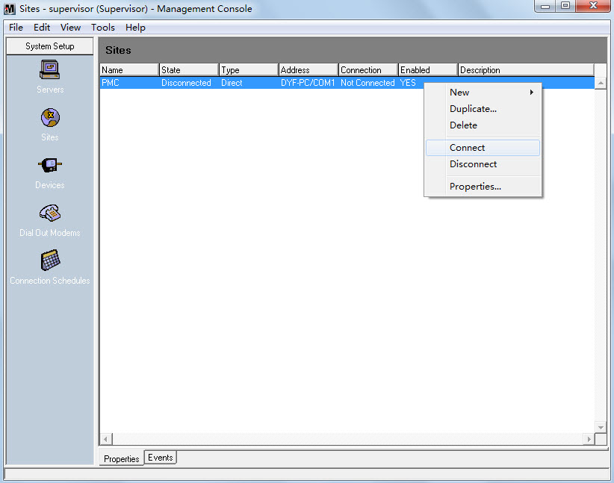
- Select the connection duration type to confirm connect.
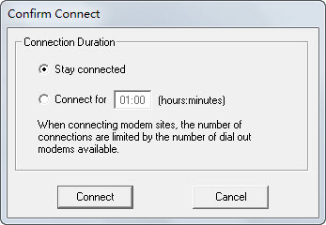
- If the communicate link is OK, it shows Connected in the State column.
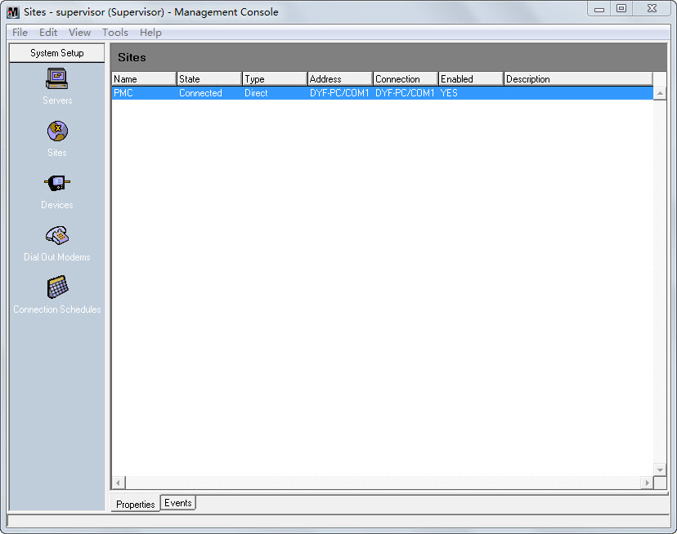
- Click the Devices icon on the left pane. Right-click in the display window and select NewSerial Device on Direct Site….
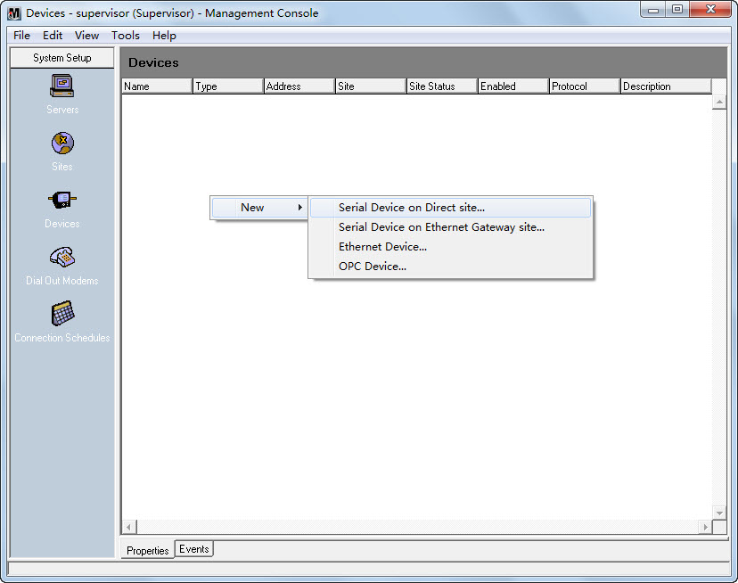
- The Serial Device Options dialog box appears as follows:
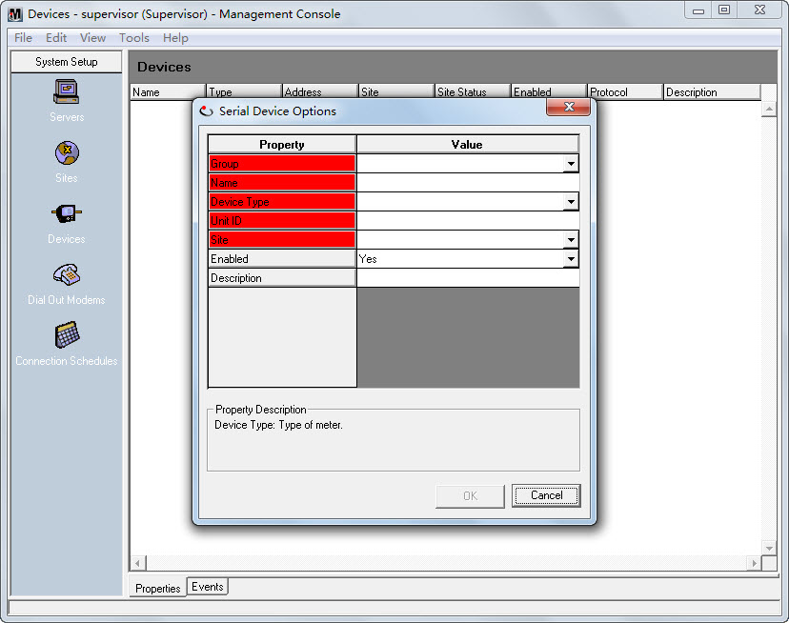
- Right-click within the dialog box and select Advanced Properties.
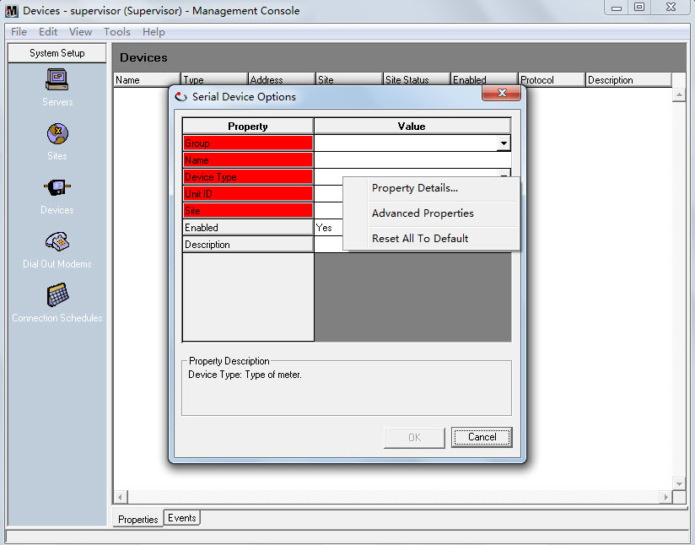
- Fill in the Group, Name, Device Type, Unit ID and Site fields.
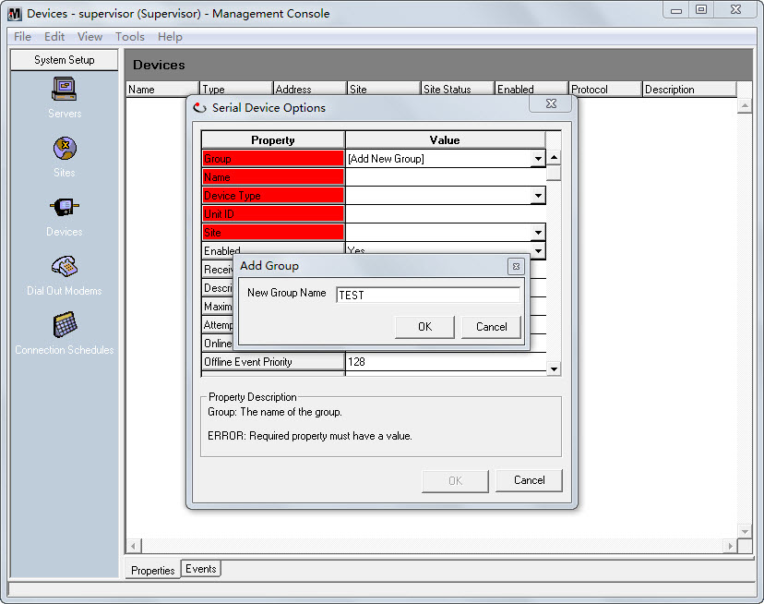
- In the Device Type field, click the drop-down button, you can find the PMC53M device type in the list. Select PMC53M for device type.
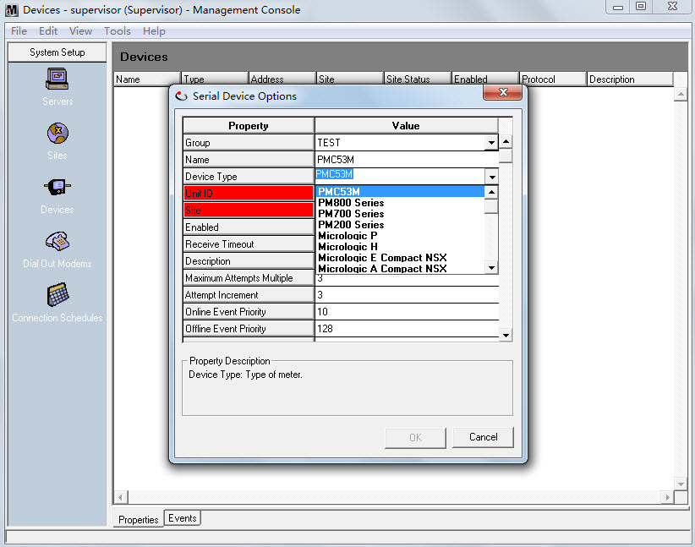
- Configure the Receive Timeout and other fields if required.
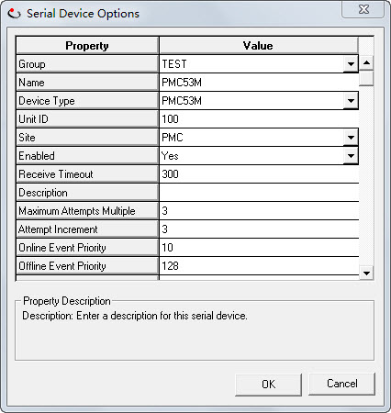
- The PMC53M direct device is shown in the right pane.
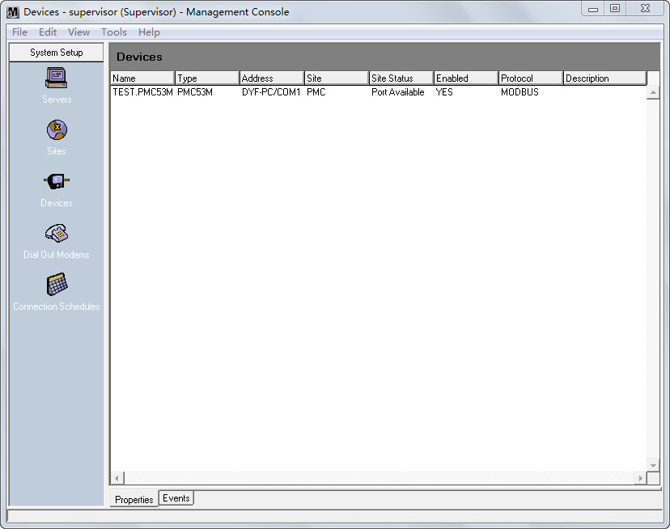
Setting Up a VIP Diagram in Designer
- Launch Designer and Open the VIP node. Make sure that Options Show Toolbox is selected in order to edit a diagram. Drag a Grouping Object from the toolbox into the VIP diagram. Double-click the grouping object to open it.
- Create the modules in the picture below.
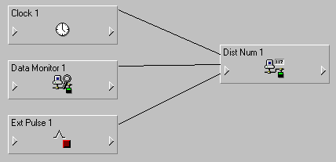
- Drag a Clock module and a Distributed Numeric module into the window. Link the LocalTime output register of the Clock module to the Source input register of the Distributed Numeric module.
- Drag a Data Monitor module into the window. Click the input symbol of the module, and click the icon on the tool bar. Double-click the PMC53M node and select a proper manager, module and output register to link a real-time parameter of PMC-53M to the Source input register of the Data Monitor module. Link the Status output register of the Data Monitor module to the Activate input register of the Distributed Numeric module.
- Drag a External Pulse module into the window. Link the Trigger output register of the Ext Pulse module to the WriteNow input register of the Distributed Numeric module.
- Right-click the Distributed Numeric module to enter the setup interface. Select the Destination setup register and then click Modify…. Navigate to the UNIX time register of PMC-53M as shown below and click OK. As shown below.
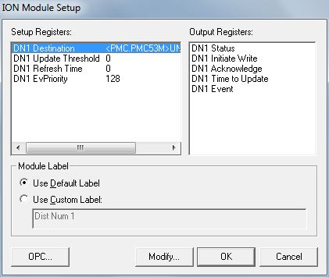
- Save changes to the node and exit.
Manually triggering time synchronization of PMC-53M in ION VISTA
- Launch VISTA. Enter the right user name and password to login.
- Select File New to create a new user diagram. Make sure that Options Show Toolbox is selected in order to edit a diagram.
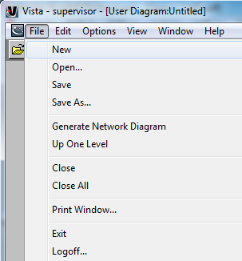
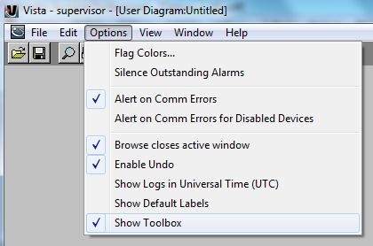
- Drag a Control Object from the tool bar to the diagram.
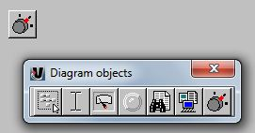
- Right-click on the Control Object and select CustomION under the Link tab and click on the Edit Link… button.
- Select the VIP node.
- Search for the Ext Pulse Module created in Designer, and select the Trigger output register, click OK to confirm.
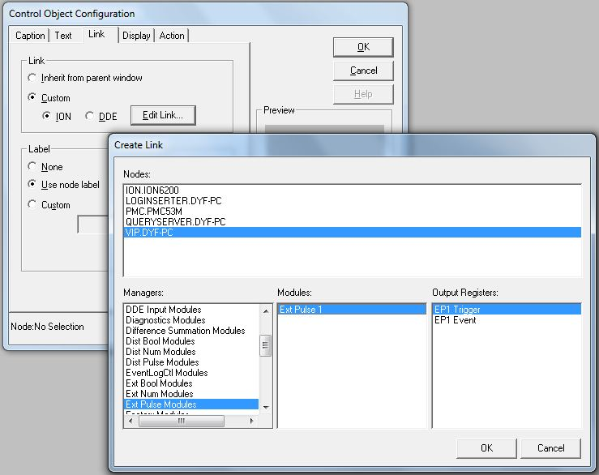
- Now the Control Object is shown as below. Double-click the image and a message box pop-up to prompt the user to confirm. Click Yes to send a pulse to trigger time synchronization.
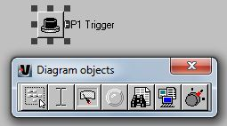
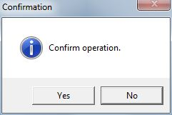
- Check the data and time from the PMC-53M’s LCD to verify its time synchronization.

